Task B2. SUM
Author: Mladen Manev
Let a be an integer. We denote by b the smallest number, which can be written using the digits of a, and denote by c the biggest number, which can be written using the digits of a. Write a program bplusc, which calculates the sum of numbers b and c.
Input
On a single line of the standard input, it is given a.
Output
On a single line of the standard output the program must write the sum of numbers b and c.
Restrictions
In 75% of the tests 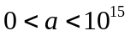.
In 25% of the tests 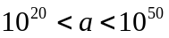.
Example
Input
201
Output
312
Explanation of the example


